Loan Underwriting Systems:

A novel Approach

A Project Report submitted to

Indian Institute of Information Technology, Allahabad

In the partial fulfilment for the

Degree of Master of Business Administration

Under the Supervision of

Dr Vineet Tiwari

By

Ayushi Asthana

[May-2020]



**INDIAN INSTITUTE OF INFORMATION TECHNOLOGY, ALLAHABAD**

**Deoghat, Jhalwa, Allahabad, U.P., India 211012**

# STUDENT'S DECLARATION

I/we hereby declare that the Tenth Semester Master Project prepared by …………………….. …titled ………………………………………… is an original piece of work done by me/us under the supervision of ……………………..

This is a purely fresh work which is done by me/us and there is no competitive work available in the academic domain/providers of items or services of the proprietary domain. I/We have taken certain information relevant to our study from various journals and books which we have listed in the References section. I/We have used certain documents for our reference.

I/we declare that the submitted work has not been undertaken elsewhere and is free from plagiarism as per the www.plagiarismdetect.com/...../.... website report.

Place: Allahabad **[Ayushi Asthana]**

Date:

# CERTIFICATE

Recommended in the partial fulfilment for the Degree of Master of Business Administration examination.

**[Dr. Vineet Tiwari]**

# 

# Checklist for Dual-Degree(MBA) project report

1. Name of Student(s) with Roll No.

Ayushi Asthana (ITM2015004)

2. Title of the Project:

Loan Underwriting Systems: A Novel Approach

3. List of Computer resources used in addition to general network-connected PC hardware

|  |  |
| --- | --- |
| Python3 IDE | Free and OpenSource |
| Anaconda Jupyter | Open Source |
| Microsoft Excel | Proprietary |
| List of libraries used(in python3)  Pandas, Seaborn, Matplotlib.pyplot, NumPy, Sklearn.preprocessing, Sklearn.model_selection, sklearn.ensemble, Skelarn.pipeline, Imblearn, XgBoost, Sklearn.svm, sklearn.linear_model | Free and open source |

4. Category of the Project & your contribution claimed

• Research Project

• Studying the performance of different machine learning technologies for loan underwriting, and developing a more consistent ensemble model to improve the baseline performance.

5. The project studies the various methods for Loan underwriting and the use of technology in the domain, we suggest improvements in the models being used and argue the case for the superiority of ensemble learning in terms of performance.

# 

# 

# Acknowledgements

This project consumed a huge amount of work, research and dedication. The implementation would not have been possible without the support of certain individuals. Therefore I would like to extend my sincere gratitude to all of them.

I would like to thank my supervisor, Dr Vineet Tiwari, for giving me the opportunity to carry out the project, and for supporting me with his expertise and experience in implementing this project.

I am also thankful for my panel Dr Vijaishri Tiwari, Dr Anurika Vaish, Dr Sudipta Das, Dr Rishish Mishra, and Dr Praikshit Joshi for their valuable insights and guidance.

I would also like to thank all the individuals who directly, or indirectly helped me out in successfully completing this project.

# Abstract

Loan underwriting is the process of a lender determining if a borrower's loan application is an acceptable risk. In this paper, we assess the performance of ensemble learning on the problem of loan classification. The problem is complicated by data imbalance and null values in the dataset. We solve these issues using Undersampling and Imputation. We perform a comparative study of some commonly used learning algorithms to establish baseline performance on the dataset and prove that a combination of high performing models creates a good ensemble and provides better accuracy, precision, and recall than the individual models. This study is meant to establish the relevance of ensemble learning for underwriting and its various advantages when compared to traditional underwriting as well as a less complex single-model learning system.

Keywords: Underwriting, Ensemble, Imbalance

# 

# Table of Contents

1. Candidate’s Declaration………………….……………………………….………..…..…1
2. Certificate from the Supervisor………………….……………………………………..1
3. Checklist for project report………………….……………………………….…………..2
4. Acknowledgement…………………………...….……………………………….…………..3
5. Abstract ……………………………………………………..…………………………………...4
6. Table of Contents…………………………………………….……………………...…….….5
7. Introduction…………………………………………………….………………….…………...6
8. Problem Definition…………………………………………....……………….…….…….. 7
9. Literature Review………………………………………………...……………...……..…8-9
10. Methodology…………………………………………………………………………….10
    1. About the dataset……………………………..……………….………….…10-11
    2. Data Analysis…...…………………………………………….………….……11-12
    3. Selection of base learners….…………………………………………… 12-14
    4. Types of Ensemble..………………………………………...…………..…..……15
    5. Modelling………………...…..……………………...……………………..………16
       1. Voting Classifier
       2. Stacking
       3. Boosting
11. Results and Conclusion………………………………………………...…………. 17
12. Future Work……………………………...………………….……………....…………18
13. References………………………………………………………..………....………… 19

# 1. Introduction

In India, outstanding credit cards' amount as of May 2010 was Rs 19,579 crore, and in June 2018 it was Rs 74,400 crore.

Despite the fact that credit accounts are an unpopular choice among Indians(Gauba, 2012), the revenue involved is significant. Therefore, we can estimate the revenue involved with traditional lending (automobile loans, student loans, home loans, personal loans, etc.). It is becoming critical to minutely assess applicants and make a wise decision. This implies that some sort of risk assessment is necessary, to ensure that the loan matches the desired risk profile of the lender.

While lending to businesses remains a complex decision, employing human resources on credit applications of low value or standard purposes seems wasteful.

Loan Repayment is a major issue not only in Indian Financial Systems but across the globe. Depending on the risk threshold and the Non-Performing Asset(NPA), Financial Institutions with bad loans may be restricted to carry out expansion in terms of branches, staff recruitment and the size of their loan book. Such protective measures hinder the growth of institutions as well as of the borrower. Automated underwriting is a smart solution to some, if not all, of these problems. It can provide assistance and make trivial decisions freeing up the human resources for more complex decision making tasks.

A well-established bank approves 4-5 lakh loans every year, the number of applications could be even higher. The average turnaround time for a loan decision used to be very high and the decisions were prone to error due to human biases. But this problem has been significantly reduced with the advent of automatic underwriters. The average turn around time of loan applications has come down from a few weeks with human underwriters to anywhere between 1 day to 10 seconds with automated systems! The personal bias of underwriters can be completely eliminated and a variety of methods are available to deal with data induced bias. (Veale and Binns, 2017).

Through the years, several methods of automated underwriting have surfaced and have been commercially used. In this paper, we perform a comparative analysis of a few such methods and demonstrate the performance of a comparatively novel machine learning technique called Ensemble Learning.

# 2. Problem Definition

Financing businesses, especially SMEs is becoming more difficult as public sector banks (PSBs) are closely scrutinized by the Prompt Corrective Action (PCA) framework of RBI. It limits lending ventures of the banks that do not handle their loan profiles too well. Eleven out of the 21 public sector banks in India were already under the banking regulation supervision and had to contend with the restricted business so far. After many mergers and pooling of assets, now four banks remain under the PCA, but the general situation hasn’t improved much.

Subject to the risk thresholds established in PCA rules, the banks are regulated from expanding the number of offices, staffing and increasing the size of their loan book. Other constraints include more provisions for bad loans and disbursal to the companies whose financing is above investment standards.

The two important questions to ask in the lending business are: 1) How risky is the borrower? 2) Given the risk, should we proceed with lending him/her? The response to the first question determines the interest rate the borrower would have. Interest rate measures among other things (such as time value of money) the riskiness of the borrower, i.e. the riskier the borrower, the higher the interest rate. Considering the interest rates, we can then conclude whether the borrower is eligible for the loan.

Investors grant loans depending on the guarantee of payment along with interest. That means the lender only makes a profit (interest) if the borrower pays off the loan. However, if he/she doesn’t repay the loan, then the lender loses money.

We’ll be using publicly available data from LendingClub.The data covers 40,000 loans funded by the platform in the FY 2017-18. The dataset contains the interest rate for each borrower, so, we’ll address the second question indirectly by trying to predict if the borrower will repay the loan by its maturity date or not. This will benefit the small and medium enterprises or startups, which usually get ruled out, post manual underwriting, from getting their loan requests approved due to RBI’s PCA.

# 

# 3. Literature review

Automated underwriting methods have cascading advantages. It allows banks to strictly scrutinize the risk profile of their loan book, efficiently recognize low-risk borrowers and use risk-based pricing to ensure positive selection bias. Moreover, it helps get rid of anomalies introduced by biases created due to human tendencies like short term investment strategies, inequality and prejudice, and a flawed decision-making criterion with regard to the social economy(Epstein, 2010). However, most lenders heavily rely on generic risk scores by credit bureaus (e.g. CIBIL, Equifax, Experian, etc.), which display an average performance in general but don’t give any advantage to anyone. They consider factors like repayment history, type of credit, age of credit, credit exposure, and credit inquiries while calculating the credit score. ("Equifax Vs CIBIL Vs Experian Vs Highmark", 2020)

These scores are often obstacles to the entrance for the “credit invisible.”(Brevoort et al., 2016). The study suggests that customers in low-income communities are more likely to have little to no credit history to produce a credit score. These segments of the society might need loans for big purchases, but their lack of credit history hinders their possibilities of approval and credit lines when underwriters use traditional credit scores to assess them: it’s a catch-22(Faggella, 2020). As the credit score calculation depends on spending and credit history, it is not a very accurate measure of the risk profile of an applicant(Tatham, 2020). So, despite being comparatively much less risky, some people may not be approved for loans, just because they are too young.

With machine learning, the number of data sources that can factor into a credit model is theoretically infinite. Brookings Institution claims, “AI along with ML and big data, supports a much larger set of data-types that can factor into the credit calculation.The data that can be considered ranges from social media activity, to the computer model being used, to clothing and favorite shopping spots.”, (Klein,2020). This helps us develop more sophisticated algorithms that are much more robust and yet flexible. We’ve seen this across a variety of lending companies offering unsecured consumer, student, or even small business loans, particularly focused on digital lending.

Ensemble Learning is a comparatively more novel form of learning algorithm which has been a favourite in Data Science competitions(Güneş et al., 2020). Ensemble systems(Nordhausen, 2013), are meta-algorithms combining different machine learning methods into a consolidated predictive model so as to minimise variance (bagging), bias (boosting) or prediction accuracy (stacking). It relies on the assumption that each model would look at a different aspect of the data which yields a part of the truth. Combining good performing models that were trained independently will capture more of the truth than a single model. Therefore, this would result in more accurate predictions and lower generalization errors. Going forward, the idea is to explore the dataset, implement different techniques and analyze the success of this particular method on the Underwriting problem.

Relative to traditional modelling techniques, machine learning models are more powerful and can be deployed much more quickly. Hence, as expected, a wide range of lenders are excited about its potential. However, building a business case around the opportunity isn’t as easy — it’s obvious that machine learning will be useful, however, the financial benefit must be weighed against the costs.

In the work of (Nikolopoulos & Duvendack, n.d.) We see a hybrid underwriting system for insurance companies. This system is a form of an expert system which uses genetic algorithms and a hybrid approach to modelling of the system. They explain how the performance of their hybrid system beats any single method used. Another study on the problem of insurance underwriting in China (Yi Tan & Guo-Ji Zhang, 2005) uses a support vector machine for classification and points out the shortcomings of the traditional systems that are handled by the machine-learning-based solution.

Neural Networks have also been used as decision-making systems in the underwriting process and have shown promising results on certain datasets. The works of (Weizhong Yan & Bonissone, 2006) analyze four different designs of neural networks and their performance on the given dataset.

One of the studies explored the idea of using machine learning as a decision-maker for investment in startups (Bogdanova, 2019). It was developed to be commercially used by investors in order to identify potentially successful startups and make wise investment decisions.

The potential of Machine Learning in financial problems has been widely explored and written about. People have various beliefs about the usability of artificial intelligence and machine learning in the field of finance, but a unanimous opinion is that they make things easier. There is ample literature available that assesses machine learning in light of application in finance and some common learning methods like Tree-Based Models (Random Forest, Gradient Boosting, Decision Trees etc.), Neural Networks and Support Vector Machines are widely used. (Bazarbash, 2019)

# 4. Methodology

## 4.1 About the Dataset

We will first look at the different features of the dataset (Dedunu & Fernando, 2020). Note that the system doesn’t account for any personal information and all applications are identified with a random alphanumeric series. This accounts for the problem of any discrimination by avoiding the direct inclusion of personal or sensitive information(Veale and Binns, 2017) in the learning system.

* **Purpose**: the Category in which the loan is applied, this parameter is considered in order to determine the risk involved in investing the money by the investor. High Risk and Low-risk lending have different criteria for the evaluation of a particular application.
* **Revolving balance**: A **revolving balance** is the part of the credit expenditure that is left outstanding at the end of a billing cycle. It is a variable amount based on borrowing and repayment of the customer
* **Inquiries in the past 6 months**: The borrower’s number of inquiries by creditors in the last 6 months. This parameter indicates the number of inquiries by the investor to the borrower because of violating one of the conditions of lending.
* **Delinquencies in the last 2 years**: the number of times the borrower had been past due on a payment in the past 2 years. This parameter indicates the delay in the instalments of the loan in the previous two years we have considered two years because this precisely gives us the best idea about the present economic condition of the borrower.
* **Public Record**: The number of derogatory public records. This parameter refers to any criminal records/derogating records/trials/etc. on the borrower's end
* **Annual Income**: The annual income of the borrower. This parameter is used to correctly access and precisely predict the present economic conditions of the borrower.
* **Interest Rate**: The interest rate of the loan (proportion).This indicates the rate of interest on which the investor has lent the money to the borrower.
* **Instalment**: Its the monthly/quarterly/yearly payments owed by the borrower that is reimbursed over time with a fixed number of scheduled payments. The term of the loan can be as small as a few months or as long as 30 years.
* **Debt-to-income ratio**: The debt-to-income ratio of the borrower. The debt-to-income ratio is one-way lenders, including mortgage lenders, measure an individual's ability to manage monthly payments and repay debts. It is determined by dividing the sum of recurring monthly debt by gross monthly income and is stated as a percentage.
* **Revolving Utilization**: The borrower’s revolving line utilization rate, also called “debt-to-limit ratio” or “credit utilization,” estimates the value of the revolving credit limits in use.
* **Loan Status**: The class variable, it can either be “Charged Off” that is the loan defaulted and couldn’t be recovered or “Fully Paid”
* **Employment Status**: This parameter indicates the employment status of the borrower.
* **Real Estate Ownership**: This parameter indicates that when in the extreme opposite economic conditions of the borrower will the borrower be able to lead an economically stable life.

## 4.2 Data Analysis

While working through the project, there was a variety of preprocessing steps needed to make the data ready for use. Issues encountered were due to the data imbalance, and the amount of missing data in application forms. This needed to be addressed in order to improve the performance of the model and ensure consistency.

The three main problems caused by missing data are:

* can introduce a substantial amount of bias,
* make the handling and analysis of the data more arduous and,
* Reduce efficiency.

Missing data(fig.2) can be tackled by deleting the tuple in the data set which has missing values, but it has many pitfalls: like if a test case has missing data then the program will give errors or the size of the data set gets reduced and proper learning is hindered. Imputation can avoid pitfalls created by listwise deletion of cases with missing values. In this process, we replace missing data with values calculated from the data available. It preserves all cases by replacing missing data with an estimated value based on other available information. Once all missing values have been imputed, the data set can then be analyzed using standard techniques for complete data.

Data imbalance(fig. 1) is one of the major problems prevailing in real-time anomaly detection datasets. A dataset is considered to be imbalanced if one of its classes plays a huge dominance over the rest of the classes. In our case also, as shown in figure _ the class distribution is skewed, which causes a bias in the learning models rendering incorrect decisions. Oversampling, under-sampling and hybrid sampling can be used to counter the imbalance.

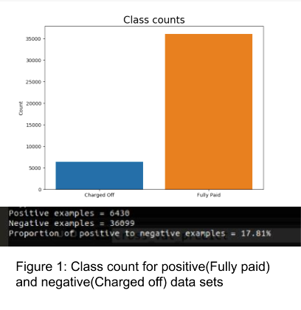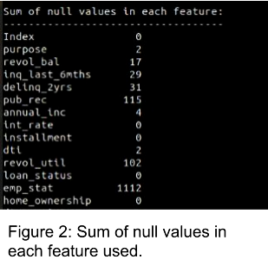

We used undersampling to reduce the number of samples in the majority class in order to overcome the imbalance in the dataset. In the real world as well, this anomaly persists, at least in some sectors of borrowing. For example, in the case of automobile loans and home loans, a majority of the loans are approved usually due to the presence of collateral.

## 4.3 Selection of Base Learners

The various models considered for the comparative study are :

* Logistic Regression: It is a statistical model that uses a logistic function to create a binary dependent variable, many more complex extensions also exist.
* Artificial Neural Network: An artificial neuron network (ANN) is a computational design based on the composition and roles of biological neural networks. Data that passes through the network changes the structure of the ANN because a neural network develops- or learns, in a way- on the basis of that input and output.
* Linear Discriminant Analysis: It considers variants in order to make predictions assuming a Gaussian distribution of mean values in each class.
* K-Nearest Neighbours: The output is a class membership. An object is classified by a plurality vote of its neighbours, with the object being assigned to the class most common among its k nearest neighbours (k is a positive integer, typically small).
* Naive-Bayes: Applying Bayes' theorem with assuming strong (naïve) independence among the features.
* Decision Tree: It is a tree-like structure, where every internal node represents a test on an attribute, each branch is the outcome of the test, and each leaf node (terminal) denotes a class label.
* Support Vector Machine: Representing each sample as points in feature space, mapped such that the samples of different classes are divided by a clear gap that is to be maximised. Test cases are then mapped into the same model for prediction based on which side of the gap they’re on.

These models were selected, mainly because of their classification power in general problems, but also on the basis of literature review.

It is important to select a diverse set of base learners for the ensemble in order to minimize correlation and increase performance. If we choose from among the top performers, the ensemble’s performance almost always goes up and can keep improving on adding more, non-correlated models. Worst case, all models are perfectly correlated, and the performance of the ensemble and the strongest model in it become identical, the performance of the ensemble could even be worse if one of the models used is particularly bad.

The correlation among the top-performing models is as shown in figure 5. Low correlation between individual models implies a higher chance of an improved performance because the results of one model are not correlated with the results of the other (TUMER & GHOSH, 1996). Hence each model among these is extracting different information from the data which contributes to its decision.

|  |  |
| --- | --- |
| Model | Cross-Validation Score(Split size = 3) |
| Logistic Regression | 64.95 |
| Random Forest Classifier | 67.82 |
| XG Boosting | 68.43 |
| Artificial Neural Network | 67.02 |
| Linear Discriminant Analysis | 64.51 |
| K-Nearest Neighbours | 62.64 |
| Naive Bayes | 57.57 |
| Decision Tree | 62.63 |
| Support Vector Machine | 66.07 |

Fig.3 ROC curve: showing the capability of class distinction in the model.

PR curve: showing the ability of the model in identifying the minority class.

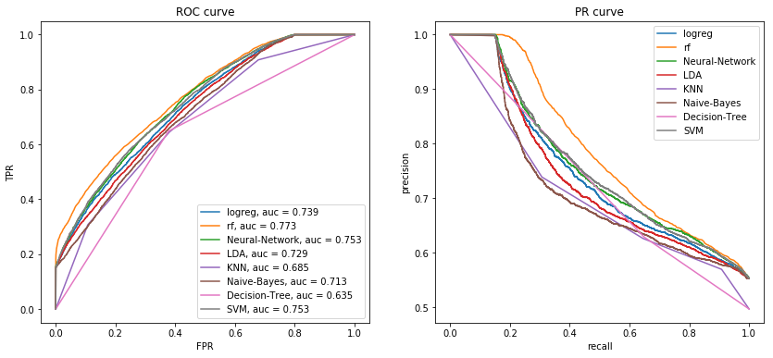 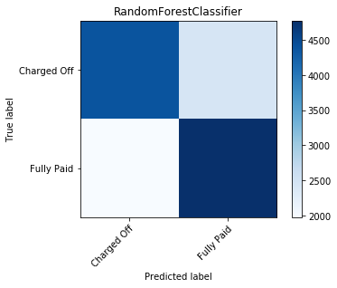

Fig. 4 Confusion matrix of chosen base learners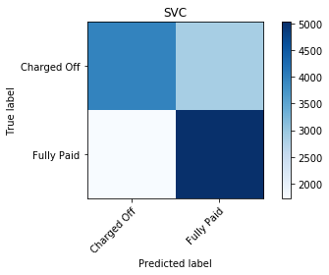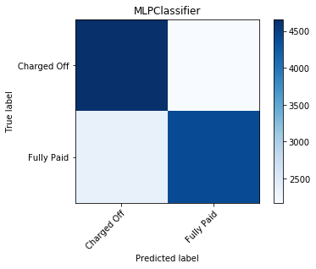

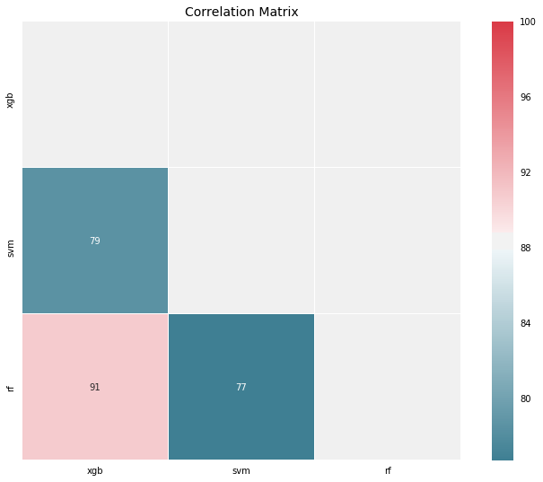

Fig. 5 Correlation matrix of top performing models

## 4.4 Types of Ensemble

There are many different types of ensemble methods that structure the constituent models in different ways. The most common among them are:

* Blending: It averages predictions from all the constituent models.
* Bagging: Using different datasets to train different models and then using majority voting to make the final decision. From the original dataset, we sample with replacement. Therefore, each dataset will comprise, on an average, 2/3 of the original data and 1/3 will be copied. Because each dataset is built on different data, they behave like different models. Random Forest, for example, enhances default bagging trees by decreasing the possibility of important features getting picked on every split. Plainly speaking, it decreases the number of features at every split by half. This reduces correlation and hence the variance.
* Boosting: Build models sequentially i.e. every model receives the residuals of the preceding one. The final output is the combined result of each model weighted by the learning rate λ. It decreases the bias from bagging by taking into account previously learned information and building upon it.
* Stacking: In this method, we build k models called base learners, then fit a meta-learner to the output of the base learners which predicts the final output.

We have studied these methods (in combination, and separately) to determine the best-suited model for our data.

As we saw from fig.1, almost all models suffer from biased results. While they are able to classify the majority much more accurately, the same is not true for the minority results.

(Also called identifying “False Positives”. )

In our case, having a “False Positive” means that we are classifying a bad loan as a good one. It goes without saying that, we don’t want a system to do this. So, in order to minimize this difference, we combine different models, much like asking for multiple opinions before making an important decision.

## 

## 

## 4.5 Modelling

### 4.5.1 Voting Classifier

We used a blending ensemble technique here by applying a soft voting method on three of the top-performing models (Random Forest, ANN, and SVM). This is a very straightforward ensemble technique where every model is considered and we accordingly assign weights to models to get better performance on the whole.



Fig. 6 Representation of Voting Algorithm

### 4.5.2 Stacking

In this case, a base layer of the three models was created and meta-features were extracted. These meta-features serve as an input to a meta-learner which, in this case,was chosen to be a Logistic Regression Classifier.



Fig. 7 Representation of Stacking Algorithm

### 4.5.3 Boosting

This third ensemble was designed to capture the most information from the data. We used a boosting method on each of the classifiers which were in turn trained with a subset of the training data(D1, D2, D3) to enhance the performance and combine their results to build a better performing model.

Fig. 8 Representation of Composite ensemble classifier.

# 5. Results and Conclusion

# 

Fig. 9 ROC and PR curve of the ensemble models

We can see, the ROC curve of the stacking classifier is only marginally better than the involved base learners, but the PR curve shows that the ensemble learners are better at identifying the minority class than the individual classifiers.

With classification problems like this, where False Negatives( i.e. a high-risk loan being classified as low-risk) are a lot more expensive than False Positives, we may want to have a model with a high recall rather than high precision. Stacked ensemble and Boosting show promising results in this regard.

It may be worthwhile to look at ensemble techniques to design models which have a more robust performance when identifying bad loans. Not only this, customization and fine-tuning the hyper-parameters along with better data formatting can lead to a better overall performance in a commercial setting.

Different types of loans have different patterns, our dataset had a mix of different loan-types to give an idea of performance on an unorganized dataset (in the worst case). In real life, the data has many more features and is much more targeted than the one available to us. Hence, we can expect the performance of the technique to improve as more refined data is presented for assessment.

# 

# 6. Future Work

With the growing need for automation and speed of task processing, automated underwriting and repayment predictions can help save resources and time. This also means institutions can direct their efforts towards efficient measures to minimize losses. The current automated underwriting technique has a lot of scope of improvement. This technique can be modified with the help of AI, to develop recommender systems that will be able to not only predict the decision, but also highlight areas of ambiguity for human review. Also, the model can be constructed with various sets of more advanced base learners to improve performance, for eg. we could enhance our stacked ensemble model by integrating Dense Neural Network and studying a wider variety of base learners as well as adding multiple layers in the Stack.

The current models all suffer from bias due to data imbalance, while there are various techniques to handle this, there is no hard and fast rule. More research in the field would deal with data handling and optimized usage to maximize output accuracy. The minimization of Type - 1 error in predictions is necessary due to the overly costly false positives in this particular application.

The system of automated underwriting is largely a server-based application, but with improving accuracies and incorporating AI, there is a scope of extending this as a client-based application in the market to facilitate easy review and feedback on a loan application directly to the customer.

The current system is, therefore, accurate, and robust but has a scope of further improvements in terms of implementation and application

# 

# 

# 7. References

* Varoquaux, G., Buitinck, L., Louppe, G., Grisel, O., Pedregosa, F., & Mueller, A. (2015). Scikit-learn. *Getmobile: Mobile Computing And Communications*, *19*(1), 29-33. https://doi.org/10.1145/2786984.2786995
* Brevoort, K., Grimm, P., & Kambara, M. (2016). Credit Invisibles and the Unscored. *SSRN Electronic Journal*. https://doi.org/10.2139/ssrn.2743007
* Gauba, R., 2012. The Indian Banking Industry: Evolution, Transformation & The Road Ahead. *Pacific Business Review International*, 5(1).
* *Equifax Vs CIBIL Vs Experian Vs Highmark*. Bankbazaar.com. (2020). Retrieved 18 February 2020, from <https://www.bankbazaar.com/equifax/equifax-cibil-experian-highmark.html>.
* Faggella, D. (2020). *Machine Learning for Underwriting and Credit Scoring – Current Possibilities | Emerj*. Emerj. Retrieved 3 February 2020, from <https://emerj.com/partner-content/machine-learning-underwriting-credit-scoring/>.
* Tatham, M. (2020). *2019 Consumer Credit Review*. Experian.com. Retrieved 5 February 2019, from <https://www.experian.com/blogs/ask-experian/state-of-credit>.
* Klein, A. (2020). *Credit denial in the age of AI*. Brookings. Retrieved 20 March 2020, from https://www.brookings.edu/research/credit-denial-in-the-age-of-ai/.
* Nordhausen, K. (2013). Ensemble Methods: Foundations and Algorithms by Zhi-Hua Zhou. *International Statistical Review*, *81*(3), 470-470. https://doi.org/10.1111/insr.12042_10
* Veale, M., & Binns, R. (2017). Fairer machine learning in the real world: Mitigating discrimination without collecting sensitive data. *Big Data & Society*, *4*(2), 205395171774353. https://doi.org/10.1177/2053951717743530
* Dedunu, H., & Fernando, A. (2020). *Factors Affecting to Performing and Nonperforming Borrower’s Loan Repayment Ability*. Dr.lib.sjp.ac.lk. Retrieved 20 March 2020, from <http://dr.lib.sjp.ac.lk/handle/123456789/7045>.
* TUMER, K., & GHOSH, J. (1996). Error Correlation and Error Reduction in Ensemble Classifiers. *Connection Science*, *8*(3-4), 385-404. DOI: 10.1080/095400996116839
* Güneş, F., Güneş, F., Jones, P., Gödde, A., & Grover, S. (2020). *Why do stacked ensemble models win data science competitions?*. The SAS Data Science Blog. Retrieved 31 March 2020, from <https://blogs.sas.com/content/subconsciousmusings/2017/05/18/stacked-ensemble-models-win-data-science-competitions/>.
* Yi Tan, & Guo-Ji Zhang. (2005). The application of machine learning algorithms in the underwriting process. *2005 International Conference On Machine Learning And Cybernetics*. DOI: 10.1109/icmlc.2005.1527552
* Weizhong Yan, & Bonissone, P. (2006). Designing a Neural Network Decision System for Automated Insurance Underwriting. *The 2006 IEEE International Joint Conference On Neural Network Proceedings*. DOI: 10.1109/ijcnn.2006.246981
* Nikolopoulos, C., & Duvendack, S. A hybrid machine learning system and its application to insurance underwriting. *Proceedings Of The First IEEE Conference On Evolutionary Computation. IEEE World Congress On Computational Intelligence*. DOI: 10.1109/icec.1994.349974
* Bogdanova, M. (2019). *Fintech Underwriting using Machine Learning* (Bachelor's). Oulu University of Applied Sciences.
* Epstein, G. (2010). The David Gordon Memorial Lecture: Finance without Financiers: Prospects for Radical Change In Financial Governance. *Review Of Radical Political Economics*, *42*(3), 293-306. DOI: 10.1177/0486613410375416
* Bazarbash, M. (2019). FinTech in Financial Inclusion: Machine Learning Applications in Assessing Credit Risk. *IMF Working Papers*, *19*(109), 1. DOI: 10.5089/9781498314428.001